**GROUP 7:**

**PATRICK AYAKO – SC211/0419/2018**

**ORINA WYCLIF - SC211/0733/2018**

**NJOROGE CHRISPUS – SC211/0684/2018**

**JOHN MWANGI KAMAU – SC211/0695/2018**

**MOSES NJUGUNA - SC211/0681/2018**

**SHADRACK KORIR – SC211/0725/2018**

**MIKE KING’ORI - SC211/0355/2018**

**FESTUS KIPKORIR – SC211/0720/2018**

**PRESENTATION ON CLOUD COMPUTING, FOG COMPUTING AND EDGE COMPUTING**

Cloud Computing provides us means of accessing the applications as utilities over the Internet. It allows us to create, configure, and customize the applications online.

## **What is Cloud?**

The term **Cloud** refers to a **Network** or **Internet.** In other words, we can say that Cloud is something, which is present at remote location. Cloud can provide services over public and private networks, i.e., WAN, LAN or VPN.

Applications such as e-mail, web conferencing, customer relationship management (CRM) execute on cloud.

## **What is Cloud Computing?**

Cloud Computing refers to **manipulating, configuring,** and **accessing** the hardware and software resources remotely. It offers online data storage, infrastructure, and application.

Cloud computing offers **platform independency,** as the software is not required to be installed locally on the PC. Hence, the Cloud Computing is making our business applications **mobile** and **collaborative.**

## **Basic Concepts**

There are certain services and models working behind the scene making the cloud computing feasible and accessible to end users. Following are the working models for cloud computing:

* Deployment Models
* Service Models

**Deployment Models**

Deployment models define the type of access to the cloud, i.e., how the cloud is located? Cloud can have any of the four types of access: Public, Private, Hybrid, and Community.

Public Cloud

The public cloud allows systems and services to be easily accessible to the general public. Public cloud may be less secure because of its openness.

Private Cloud

The **private cloud** allows systems and services to be accessible within an organization. It is more secured because of its private nature.

#### Community Cloud

The **community cloud** allows systems and services to be accessible by a group of organizations.

#### Hybrid Cloud

The **hybrid cloud** is a mixture of public and private cloud, in which the critical activities are performed using private cloud while the non-critical activities are performed using public cloud.

**Service Models**

Cloud computing is based on service models. These are categorized into three basic service models which are -

* Infrastructure-as–a-Service (IaaS)
* Platform-as-a-Service (PaaS)
* Software-as-a-Service (SaaS)

**Anything-as-a-Service (XaaS)** is yet another service model, which includes Network-as-a-Service, Business-as-a-Service, Identity-as-a-Service, Database-as-a-Service or Strategy-as-a-Service.

The **Infrastructure-as-a-Service (IaaS)** is the most basic level of service. Each of the service models inherit the security and management mechanism from the underlying model,

#### Infrastructure-as-a-Service (IaaS)

**IaaS** provides access to fundamental resources such as physical machines, virtual machines, virtual storage, etc.

#### Platform-as-a-Service (PaaS)

**PaaS** provides the runtime environment for applications, development and deployment tools, etc.

#### Software-as-a-Service (SaaS)

**SaaS** model allows to use software applications as a service to end-users.

## **History of Cloud Computing**

The concept of **Cloud Computing** came into existence in the year 1950 with implementation of mainframe computers, accessible via **thin/static clients.** Since then, cloud computing has been evolved from static clients to dynamic ones and from software to services.

## **Benefits**

Cloud Computing has numerous advantages. Some of them are listed below -

* One can access applications as utilities, over the Internet.
* One can manipulate and configure the applications online at any time.
* It does not require to install a software to access or manipulate cloud application.
* Cloud Computing offers online development and deployment tools, programming runtime environment through **PaaS model.**
* Cloud resources are available over the network in a manner that provide platform independent access to any type of clients.
* Cloud Computing offers **on-demand self-service.** The resources can be used without interaction with cloud service provider.
* Cloud Computing is highly cost effective because it operates at high efficiency with optimum utilization. It just requires an Internet connection
* Cloud Computing offers load balancing that makes it more reliable.

## **Risks related to Cloud Computing**

Although cloud Computing is a promising innovation with various benefits in the world of computing, it comes with risks. Some of them are discussed below:

### Security and Privacy

It is the biggest concern about cloud computing. Since data management and infrastructure management in cloud is provided by third-party, it is always a risk to handover the sensitive information to cloud service providers.

Although the cloud computing vendors ensure highly secured password protected accounts, any sign of security breach may result in loss of customers and businesses.

### Lock In

It is very difficult for the customers to switch from one **Cloud Service Provider (CSP)** to another. It results in dependency on a particular CSP for service.

### Isolation Failure

This risk involves the failure of isolation mechanism that separates storage, memory, and routing between the different tenants.

### Management Interface Compromise

In case of public cloud provider, the customer management interfaces are accessible through the Internet.

### Insecure or Incomplete Data Deletion

It is possible that the data requested for deletion may not get deleted. It happens because either of the following reasons

* Extra copies of data are stored but are not available at the time of deletion
* Disk that stores data of multiple tenants is destroyed.

## **Characteristics of Cloud Computing**

There are four key characteristics of cloud computing:

### On Demand Self Service

Cloud Computing allows the users to use web services and resources on demand. One can logon to a website at any time and use them.

### Broad Network Access

Since cloud computing is completely web based, it can be accessed from anywhere and at any time.

### Resource Pooling

Cloud computing allows multiple tenants to share a pool of resources. One can share single physical instance of hardware, database and basic infrastructure.

### Rapid Elasticity

It is very easy to scale the resources vertically or horizontally at any time. Scaling of resources means the ability of resources to deal with increasing or decreasing demand.

The resources being used by customers at any given point of time are automatically monitored.

### Measured Service

In this service cloud provider controls and monitors all the aspects of cloud service. Resource optimization, billing, and capacity planning etc. depend on it.

**Application of Cloud Computing**

Based on the research by Simplilearn (2021) there are several applications of Cloud computing including and not limited to:

1. Online Data Storage

Cloud Computing allows storage and access to data like files, images, audio, and videos on the cloud storage. In this age of big data, storing huge volumes of business data locally requires more and more space and escalating costs. This is where cloud storage comes into play, where businesses can store and access data using multiple devices.

The interface provided is easy to use, convenient and has the benefits of high speed, scalability, and integrated security.

2. Backup and Recovery

Cloud service providers offer safe storage and backup facility for data and resources on the cloud. In a traditional computing system, data backup is a complex problem, and often, in case of a disaster, data can be permanently lost. But with cloud computing, data can be easily recovered with minimal damage in case of a disaster.

3. Big Data Analysis

One of the most important applications of cloud computing is its role in extensive data analysis. The extremely large volume of [big data](https://www.simplilearn.com/what-is-big-data-analytics-article) makes it impossible to store using traditional data management systems. Due to the unlimited storage capacity of the cloud, businesses can now store and analyze big data to gain valuable business insights.

4. Testing and Development

Cloud computing applications provide the easiest approach for testing and development of products. In traditional methods, such an environment would be time-consuming, expensive due to the setting up of IT resources and infrastructure, and needed manpower. However, with cloud computing, businesses get scalable and flexible cloud services, which they can use for product development, testing, and deployment.

5. Antivirus Applications

With Cloud Computing comes cloud antivirus software which is stored in the cloud from where they monitor viruses and malware in the organization’s system and fixes them. Earlier, organizations had to install antivirus software within their system and detect security threats.

6. E-commerce Application

Ecommerce applications in the cloud enable users and e-businesses to respond quickly to emerging opportunities. It offers a new approach to business leaders to make things done with a minimum amount and minimal time. They use cloud environments to manage customer data, product data, and other operational systems.

**FOG AND EDGE COMPUTING**

Cloud computing technology alone is not effective enough to store and process massive amounts of data and respond quickly.

For example, in the Tesla self-driving car, the sensor constantly monitors certain regions around the car. If it detects an obstacle or pedestrian on its way, then the car must be stopped or move around without hitting. When an obstacle is on its way, the data sent through the sensor must be processed quickly and help the car to detect before it hits. A little delay in detection could be a major issue. To overcome such challenges, edge computing and fog computing are introduced.

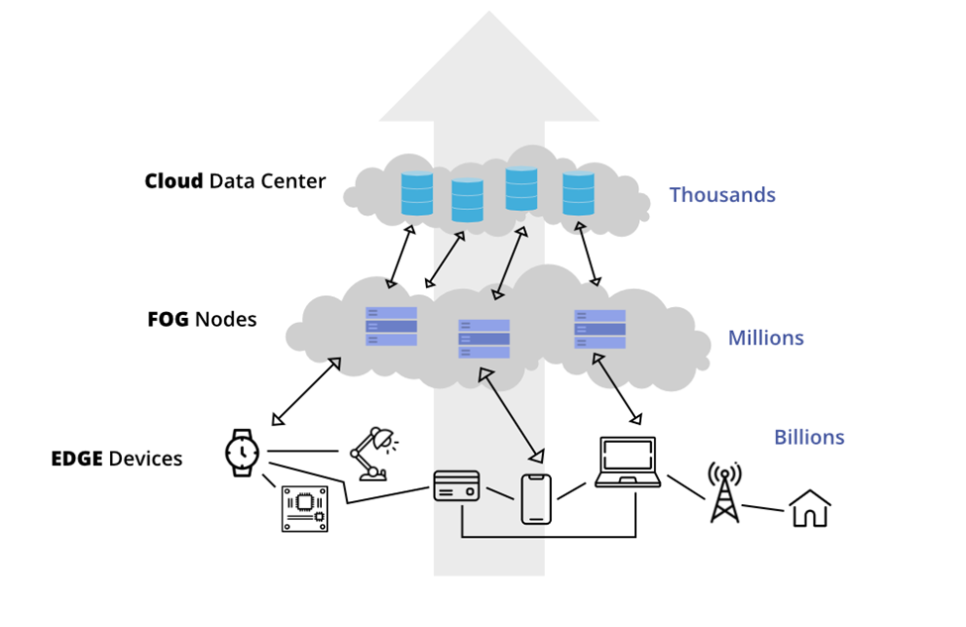

**Fog computing** optimizes cloud environments by processing data at the edge of networks, nearer to the data source.

**Edge computing** aims at bringing processing closer to the data source without sending it to the fog or centralized system for processing. With edge, computing and storage systems reside at the edge as well, but as close as possible to the component, device or application generating the data

**Architecture of Fog Computing**

The Fog computing architecture consists of physical and logical elements in the form of hardware and software to implement IoT (Internet of Things) networks. As shown in the figure below, it is composed of IoT devices, fog nodes, fog aggregation nodes with the help of fog data services, remote cloud storage and local data storage server/cloud. Let us understand fog computing architecture components.

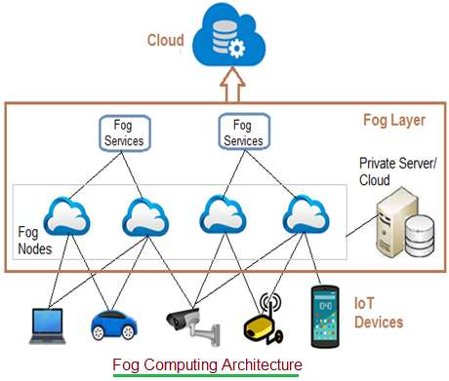

• **IoT devices**: These are devices connected on an IoT network using various wired and wireless technologies. These devices produce data regularly in huge amounts. There are numerous wireless technologies used in IoT which include Zigbee, Zwave, RFID, 6LoWPAN, HART, NFC, Bluetooth, BLE, NFC, ISA-100.11A etc. IoT protocols used include IPv4, IPv6, MQTT, CoAP, XMPP, AMQP etc.

• **Fog Nodes**: Any device with computing, storage and network connectivity is known as fog node. Multiple fog nodes are spread across larger regions to provide support to end devices. Fog nodes are connected using different topologies. The fog nodes are installed at various locations as per different applications such as on floor of a factory, on top of power pole, alongside a railway track, in vehicles, on oil rig and so on. Examples of fog nodes are switches, embedded servers, controllers, routers, cameras etc. Highly sensitive data are processed at these fog nodes.

• **Fog aggregate nodes**: Each fog node has their aggregate fog node. It analyzes data in seconds to minutes. IoT data storage at these nodes can be of duration in hours or days. Its geographical coverage is wider. Fog data services are implemented to implement such aggregate node points. They are used to address average sensitive data.

• **Remote Cloud**: All the aggregate fog nodes are connected with the cloud. Time insensitive data or less sensitive data are processed, analyzed and stored at the cloud.

• **Local server and cloud**: Often fog computing architecture uses private server/cloud to store the confidential data of the firm. These local storages are also useful to provide data security and data privacy.

**Operations of Fog Computing**

As we know there are three types of data, most time sensitive data, less time sensitive data and time-insensitive data. Fog computing architecture works based on the type of data it receives. Nearest fog nodes take data input from the devices. Let us understand the working of fog computing architecture.

➨Most time sensitive data are handled by nearest fog node to end device which has generated the data. After the received data is analyzed, a decision or action is transmitted to the device. After this, fog node sends and stores a summary to the cloud for future analysis. The data at the fog node is analyzed in a fraction of a second.

➨Less time sensitive data is sent to aggregate node for analysis. After analysis is performed, the aggregate node sends decision or action to the device through the nearest node. Aggregate fog node takes seconds or minutes to complete the analysis. The aggregate node later sends the report to the cloud for future analysis purposes.

➨The time insensitive data can wait for longer duration (in hours, days or weeks). The data is sent to the cloud for storage and future analysis.

**Applications of fog computing:**

1. Connected cars

Self-driven or self-autonomous cars are now available in the market and they produce a large amount of data. The data needs to be analyzed and processed quickly based on the information provided like traffic, driving conditions, climate etc., All this data is processed quickly with the help of fog computing. Other data like vehicle maintenance, tracking are sent directly to the manufacturer. Both edge and endpoint communication is made possible with the help of connected cars.

1. Real-time analytics

Data can be transferred from the place it is created to different places using fog computing deployments. Fog computing is used for real-time analytics which transfers the data from manufacturing systems to financial institutions which use real-time data.

1. Smart Grid

The smart electric grid is the best example of grid computing. Electrical grids are smart and dynamic these days. It will be responsive while needing less production and electrical consumption. Fog computing is ideal in a situation where the data is generated from a remote location, it can be processed there itself than carrying it to data centers. Some of the data may be generated from single sensors or a group of sensors and it can be processed there to avoid overloading the cloud.

1. Video surveillance

The most prevalent example of fog computing is perhaps video surveillance, given that continuous streams of videos are large and cumbersome to transfer across networks. The nature of the involved data results in latency problems and network challenges. Costs also tend to be high for storing media content. Video surveillance is used in malls and other large public areas and has also been implemented in the streets of numerous communities. Fog nodes can detect anomalies in crowd patterns and automatically alert authorities if they notice violence in the footage (Ramya 2022).

**Edge computing**

Edge Computing makes sure that the computational and data storage centers are closer to the edge of the topology. But what is this edge after all? The edge may be the network edge where the device communicates with the internet or where the local network which contains the device communicates with the internet. Whatever the edge, the important part of edge computing is that the computational and data storage centers are geographically close to the devices where the data is created or where it is consumed.

This is a better alternative than having these storage centers in a central geographical location which is actually thousands of miles from the data being produced or used. Edge Computing ensures that there is no **latency** in the data that can affect an application’s performance, which is even more important for real-time data. It also processes and stores the **data locally** in storage devices rather than in central cloud-based locations which means companies also save money in data transmission.

**Architecture of Edge Computing**

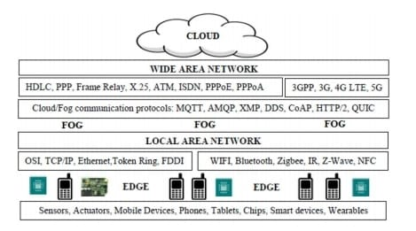

1. Device Edge - The actual devices running on-premises at the edge such as cameras, sensors, and other physical devices that gather data or interact with edge data. Simple edge devices gather or transmit data, or both. The more complex edge devices have processing power to do additional activities. In either case, it is important to be able to deploy and manage the applications on these edge devices. Examples of such applications include specialized video analytics, deep learning AI models, and simple real time processing applications. IBM’s approach (in its [IBM Edge Computing](https://www.ibm.com/support/knowledgecenter/SSBS6K_3.2.0/supported_environments/edge_devices/edge_devices.html) solutions) is to deploy and manage containerized applications on these edge devices.
2. Local Edge  
   The systems running on-premises or at the edge of the network. The edge network layer and edge cluster/servers can be separate physical or virtual servers existing in various physical locations or they can be combined in a hyperconverged system. There are two primary sublayers to this architecture layer. Both the components of the systems that are required to manage these applications in these architecture layers as well as the applications on the device edge will reside here.
   * *Application layer:* Applications that cannot run at the device edge because the footprint is too large for the device will run here. Example applications include complex video analytics and IoT processing.
   * *Network layer:* Physical network devices will generally not be deployed due to the complexity of managing them. The entire network layer is mostly virtualized or containerized. Examples include routers, switches, or any other network components that are required to run the local edge.
3. Cloud  
   This architecture layer is generically referred to as the cloud but it can run on-premise or in the public cloud. This architecture layer is the source for workloads, which are applications that need to handle the processing that is not possible at the other edge nodes and the management layers. Workloads include application and network workloads that are to be deployed to the different edge nodes by using the appropriate orchestration layers.

**Operations of Edge Computing**

Edge computing works by capturing and processing information as close to the source of the data or desired event as possible. It relies on sensors, computing devices and machinery to collect data and feed it to edge servers or the cloud. Depending on the desired task and outcome, this data might feed analytics and machine learning systems, deliver automation capabilities or offer visibility into the current state of a device, system or product.Most data calculations take place in the cloud or at a datacenter. However, as organizations migrate to an edge model with IoT devices, there’s a need to deploy edge servers, gateway devices and other gear that reduce the time and distance required for computing tasks—and connect the entire infrastructure. Part of this infrastructure may include smaller edge data centers located in secondary cities or even rural areas, or cloud containers that can easily be moved across clouds and systems, as needed.

### Advantages of Edge Computing

1. Decreased Latency

Edge computing can reduce the latency for devices as the data is processed and stored closer to the device where it is generated and not in a faraway data storage center. Let’s use the example of personal assistants given above. If your personal assistant has to send your request to the cloud and then communicate with a data server in some part of the world to obtain the answer you want and then relay that answer to you, it will take a lot more time. Now, if edge computing is utilized, there will be less latency as the personal assistant can easily obtain your answer from a nearby data storage center. That’s like running halfway around the world vs running to the edge of your city. Which is faster?!

2. Decreased Bandwidth Costs

These days all devices installed in homes and offices like cameras, printers, thermostats, AC’s, or even toasters are smart devices! In fact, there might be around 75 billion IoT devices installed worldwide by 2025. All these IoT devices generate a lot of data that is transferred to the cloud and far-off data storage centers. This requires a lot of bandwidth. But there is only a limited amount of bandwidth and other cloud resources and they are all expensive. In such a scenario, Edge Computing is a god sent as it processes and stores the data locally rather than in central cloud-based locations which means companies also save money in bandwidth costs.

3. Decreased Network Traffic

As we have already seen, there is an insane amount of IoT devices available currently with a projected increase to 75 billion in 2025. When these many IoT devices generate data that is transferred to and from the cloud, naturally there is an increase in the network traffic which results in bottlenecks of data and higher strain on the cloud. Imagine lots of traffic on a busy highway? What will happen? Large traffic jams and lots of time in getting anywhere. That’s exactly what happens here! This network traffic results in increased data latency. So the best solution is using edge computing which processes and stores the data locally rather than in far away cloud-based data storage centers. If the data is stored locally, it is much easier to access leading to decreased global network traffic and decreased data latency as well.

### Disadvantages of Edge Computing

Let’s check out some of the disadvantages of Edge Computing:

1. Reduced Privacy and Security

Edge Computing can lead to issues in data security. It is much easier to secure data that is stored together in a centralized or cloud-based system as opposed to data that is stored in different edge systems in the world. It’s the same concept that it is much easier to secure a pile of money in one location with the best cutting edge technology than it is to secure smaller piles of money at the same efficiency level. So companies using Edge Computing should be doubly conscious about security and use data encryption, VPN tunneling, access control methods, etc. to make sure the data is secure.

2. Increased Hardware Costs

Edge computing requires that the data is stored locally in storage centers rather than in central cloud-based locations. But this also requires much more local hardware. For example, while an IoT camera just needs a basic build in hardware locally to send raw video data to a cloud web server where much more complex systems are used to analyze and save this video. But if Edge computing is used, then a sophisticated computer with more processing power will be needed to locally analyze and save this video. However, the good news is that hardware prices are continually dropping which means it is much easier now to build sophisticated hardware locally.

### Applications of Edge Computing in Various Industries

1. Healthcare

There are a lot of wearable IoT devices in the healthcare industry such as fitness trackers, heart monitoring smartwatches, glucose monitors, etc. All of these devices collect data every second which is then analyzed to obtain insights. But it is useless if the data analysis is slow for this real-time data. Suppose that the heart monitor picks up the data for a heart attack but it takes a little time to analyze it? This can be catastrophic! That is why Edge Computing is so important in Healthcare so that the data can be analyzed and understood instantly. An example of this is GE Healthcare, a company that uses NVIDIA chips in its medical devices to utilize edge computing in improving data processing.

2. Transportation

Edge computing has lots of applications in the Transportation Industry, particularly in Self-Driving cars. These autonomous cars require lots of sensors ranging from 360-degree cameras, motion sensors, radar-based systems, GPS, etc. to make sure they work correctly. And if the data from these sensors is transferred to a cloud-based system for analysis and then retrieved back by the sensors, this may lead to a time lag which can be fatal in a self-driving car. In the time that it takes to analyze the data that there is a tree in front, the car may even crash into that tree! So Edge computing is very useful in autonomous cars as data can be analyzed from nearby data centers which reduces the time lag in the car.

3. Retail

Many retail stores these days are going tech-savvy! This means that customers can swipe into the store with their phone app or a QR code and starting picking whatever they want to buy. Then customers can just exit the store and the price of whatever they have bought will be automatically deducted from their balance. Stores can do this using a combination of motion sensors and in-store cameras to analyze what all customers are buying. But this also requires Edge Computing as to much time lag in data analysis can lead to the customers just picking up stuff and leaving for free! One example of this is the Amazon Go store which was first launched in January 2018.

**References:**

<https://www.networkworld.com/article/3224893/what-is-edge-computing-and-how-it-s-changing-the-network.html>

[Architecture of fog computing - <https://www.rfwireless-world.com/Terminology/Fog-Computing-Architecture-working.html>]

[Operations of fog computing - <https://www.rfwireless-world.com/Terminology/Fog-Computing-Architecture-working.html>]

Uzoma, O. J. (2015). Fog Computing.

Mohd Pakhrudin, N. S., Kassim, M., & Idris, A. (2021). A review on orchestration distributed systems for IoT smart services in fog computing. *International Journal of Electrical & Computer Engineering (2088-8708)*, *11*(2).

Alizadeh, M., Hassan, W. H., Behboodian, N., & Karamizadeh, S. (2013). A brief review of mobile cloud computing opportunities. *Research Notes in Information Science*, *12*, 155-160.

https://www.simplilearn.com/applications-of-cloud-computing-articl